Safety and Rules – The Foundation of Every Great Player
Before learning advanced shots or strategy, every new pickleball player should develop a solid understanding of safety and the basic rules of the game. These fundamentals not only make learning easier—they also help prevent injuries and build confidence on the court.
In the complete Pickleball for Beginners manual, you'll learn the essential safety principles every player should know, including proper ready position, partner communication, eye protection, safe court movement, and Coach Tom's "Safety First" philosophy. You'll also find easy-to-follow explanations of the official rules, scoring, serving, the double-bounce rule, the Non-Volley Zone (Kitchen), line calls, court etiquette, and good sportsmanship.
As a sample of what's included in the manual, we've provided two of the most important beginner lessons:
- 2.4 – Keep Your Paddle Up – Learn why proper paddle position helps you react faster, protect yourself from fast shots, and become a more confident player.
- 4.2 – The Drop Serve – Understand the fundamentals of a legal serve and how to start every point with confidence.
These two lessons are just a small introduction to the complete Pickleball for Beginners manual, which contains full-color illustrations, step-by-step instruction, coaching tips, practice ideas, and safety-first guidance designed to help you build a strong foundation and enjoy the game for years to come.
Remember: Play safely today so you can play again tomorrow.

2.4 Keep Your Paddle Up
One of the simplest habits that improves both safety and performance is keeping your paddle up whenever you're near the kitchen line.
A paddle held in front of your body:
- Helps you react faster.
- Makes blocking easier.
- Protects your face and upper body.
- Keeps you ready for the next shot.

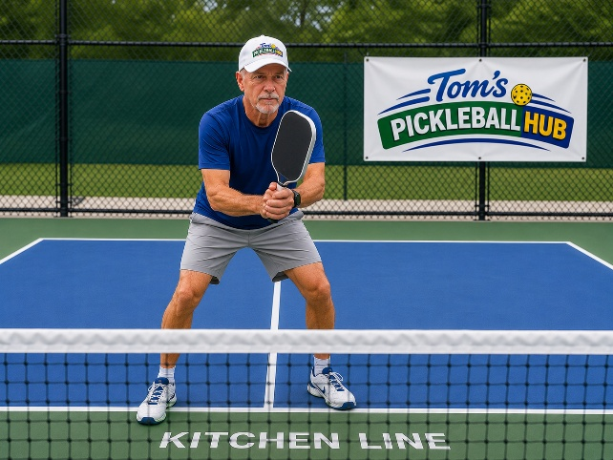

An Excerpt from My Beginner's Manual

4.3 The Drop Serve

To Perform a Drop Serve
- Hold the ball at any height.
- Release the ball naturally—do not throw or propel it upward, downward, or in any direction. Applying force to the ball as you release it results in a fault.
- Strike the ball after it has bounced.
- The serve must still meet all other serving requirements, including landing in the correct diagonal service court.
Coach Tom's Tip:
The Drop Serve is often easier for beginners because you don't have to coordinate dropping and striking the ball at the same time. It allows you to focus on developing a smooth, consistent serve with greater confidence.
The Drop Serve can make serving easier for many beginners.
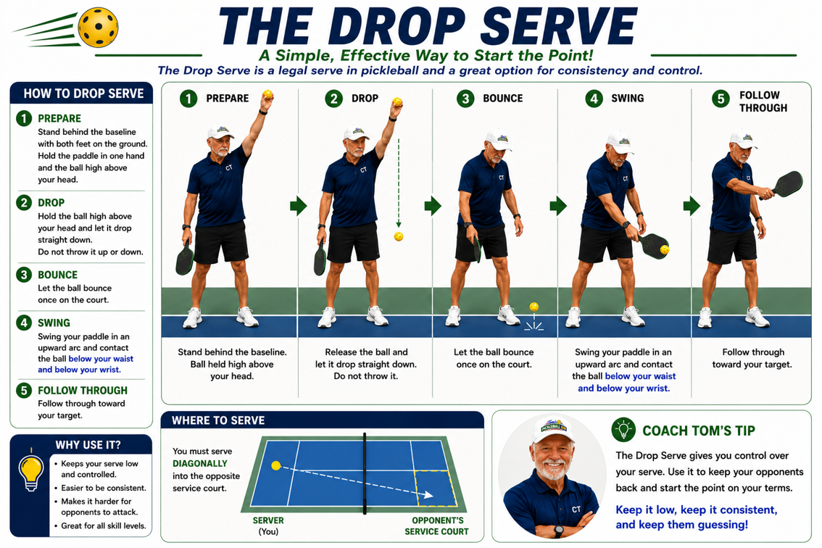

✅ Coach Tom's Beginner Checklist
Before every game, ask yourself...
☐ I have my protective eyewear on.
☐ I'm wearing proper court shoes.
And during the game…
☐ My paddle is up and in front when I'm near the kitchen line.
☐ I'm staying in an athletic ready position with my weight slightly forward.
☐ I communicate with my partner using "Mine" and "Yours."
☐ I never ever back up.
☐ I call the score clearly before serving.
☐ I make honest line calls—if I'm not sure, the ball is IN.
☐ I wait until the court is clear before entering or crossing another court.
☐ I remember to have fun, encourage others, and play safely today so I can play again tomorrow.

Coach Tom's Golden Rule
Never back up. Turn and move to the ball whenever possible. Most beginner injuries happen when players backpedal instead of turning and moving safely.

